**No Of Visualizations/ Graphs**

* Population record types of countries

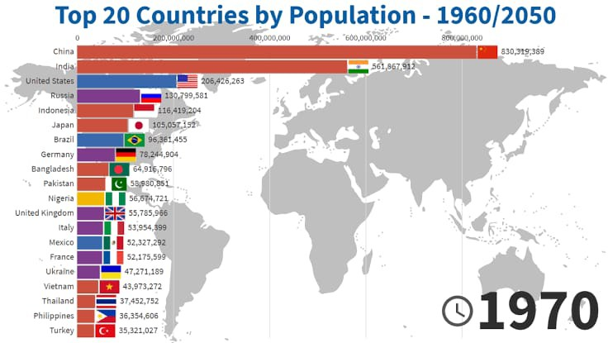

* + Population trends over the years

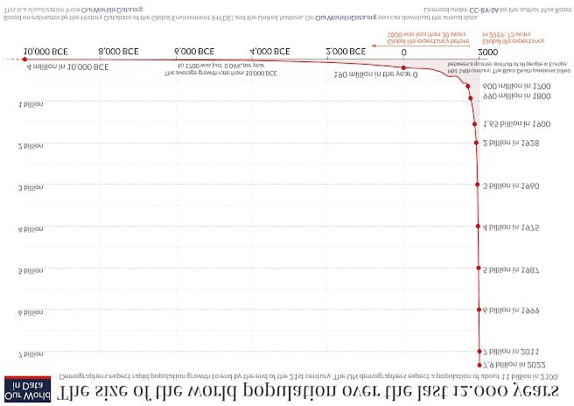

* + Population trends over the years by sex

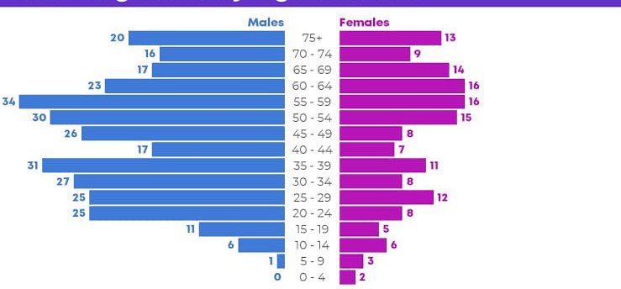

* + - Cities with highest average population

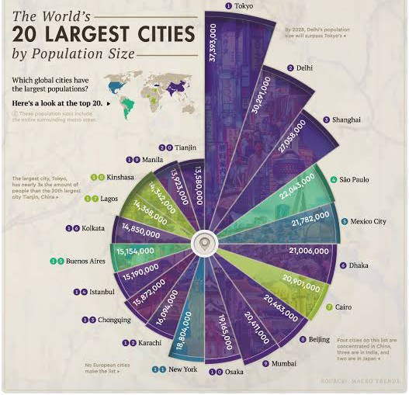

* + Countries with highest avg population from 2000 - 2014

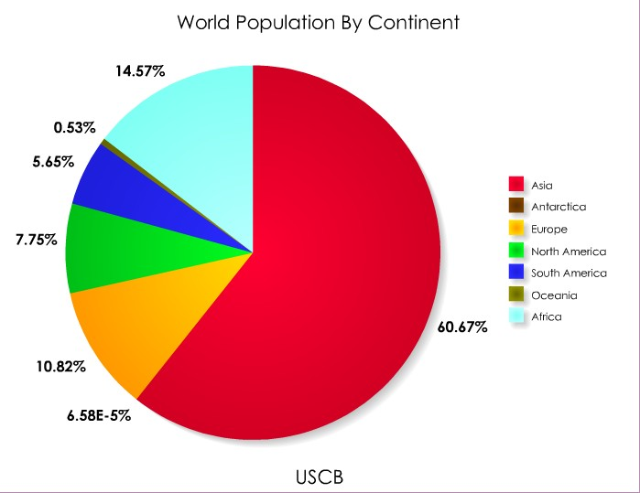

* + - Population by city type

